Lab 9 Nonlinear Circuits: Log Amps

In the days before slide rules, calculators and computers, complex mathematical functions such as division, square roots and powers were solved using logarithmic tables. Two of the most common properties of logarithms reduced multiplication and division to addition and subtraction. These are

Log(AB) = Log(A) + Log(B)
Log(A/B) = Log(A) - Log(B).

We have already seen in Lab 2 how summing and difference op-amp circuits can add and subtract. Provided a log op-amp circuit exists, the above relationships can be used to build multiply and divide circuits.
The diode introduced in lab 3 displays a nonlinear response in the current-voltage characteristic curve. When forward biased, the diode current is exponentially related to the voltage across the diode.
I_{d} = i_{o} exp(V_{d}/a) Equation 9-1
where i_{o} is the reverse bias diode current (a constant) and a= kT/e. Solving for V yields a natural logarithmic relationship between the voltage across the diode and the current passing through the diode.
V_{d} = a log_{e} (I_{d}/I_{o}) Equation 9-2

Log Op-Amp Circuit
A log op-amp circuit can be build by replacing the feedback resistor of the inverting amplifier with a diode.

Figure 9-1 Schematic Diagram of an Op-Amp Logarithmic Circuit

For the input loop, the current is i₁ = V_{in}/ R₁ Equation 9-3
For the feedback loop, the current i_{f} is I_{d} and V_{out} is V_{d} Equation 9-4
At the summing point i₁ = - I_{f} Equation 9-5
Together these equation are i₁ = V_{in}/R₁ = - i_{f} = -I_{d} = - i_{o} exp(V_{out} /a) Equation 9-6
and solving for V_{out} yields
V_{out} = a log_{e} (V_{in}/ i_{o} R₁) Equation 9-7

With the careful diode selection, this expression is valid over 5 - 6 decades. Diodes such as 1N914 and some common transistors (2N3900A) with the base and collector pins tied together, work well. The constant 'a' is about 0.059 volts at room temperature and i_{o} is typically 10⁻¹¹ amps.

LabVIEW Demo 9.1 Log OpAmp Circuit

Load the program called LogOpAmp.vi from the chapter 9 program library. Click on the [Run] button to activate the circuit. Investigate the output voltage as the input is varied over five decades of voltage levels.

Figure 9-2 LabVIEW Simulation - Op-Amp Logarithmic Circuit

This VI is an exact op-amp simulation of equation 9.7 using the typical values for 'a' and i_{o}. To convert the input voltage (1.000 volt) into the natural logarithm for 'one', requires that the output be scaled so that log_{e} (1 volt) does in fact yield the numeric value ln(1) = 0.000. A second program entitled Ln.vi scales the output of LogOpAmp.vi to generate the correct natural logarithm values. A further scaling is required to convert the natural logarithm base(e) into the normal logarithm base(10). A third program LogN.vi further scales LogOpAmp.vi to demonstrate how a input voltage is converted into a numeric log value. The scaling and conversion factors are found in a subVI called Scaling.vi. It uses the op amp circuits for subtraction and multiplication by a constant found in Lab 2.

An Analog Decibel Calculator

Many analog measurements require that a signal be measured in decibels. Recall from Lab 4, a decibel is defined as N(dB) = 20 log(V_{out}/ V₀) where V₀ is a reference voltage. One can use two log amps and the difference circuit from chapter 2 to build an analog decibel conversion circuit.

Figure 9-3 Schematic Diagram of an Op-Amp Decibel Analog Calculator

The op-amp circuit shown above calculates the logarithmic ratio log (V/V_{o}). This is a common calculation used in many applications especially in photometery. By replacing the resistor R* with 20 R, the above circuit calculates decibels. The equivalent LabVIEW simulation for the decibel calculator uses two log amps, a difference function and a multiplication by 20. The following figure shows the strong similarity of the LabVIEW simulation (diagram page) with the schematic diagram (figure 9-3) for an op-amp decibel calculator.
Figure 9-4 LabVIEW Diagram of an Op-Amp Decibel Calculator

LabVIEW Demo 9.2 Decibel Calculator
Load the program called Decibel.vi from the chapter 9 program library. Enter the output voltage and the reference voltage. Click on the [Run] button to execute a calculation. If V is the output voltage and V₀ is the reference voltage for this op-amp circuit, then the calculation gives the gain in decibels.

Exponential Op-Amp Circuit
You may have noticed the symmetry of interchanging a special component between the feedback and input loop. For example, a capacitor in the feedback loop yields an integrator while a capacitor in the input loop yields a differentiator. Diodes also have this symmetry property. A diode in the feedback loop yields a log amp circuit while a diode in the input loop yields an exponential circuit.
Figure 9-5 Schematic Diagram of an Op-Amp Exponential Circuit

For the input loop, the current is i₁ = i_{o} exp(V_{in} /a) Equation 9-8
For the feedback loop, the current is V_{out} = - i_{f} R_{f} Equation 9-9
At the summing point i₁ = - i_{f} Equation 9-10
Together these equations are i_{o} exp(V_{in} /a) = i₁ = -i_{f} = V_{out} /R_{f} Equation 9-11

V_{out} = i_{o} R_{f} exp(V_{in}/a) Equation 9-12

This circuit provides the antilog or exponential function which can be used to convert a log sum or difference back into simple numbers.

AntiLog {Log(AB)} = AB Equation 9-13
AntiLog {Log(A/B)} = A/B Equation 9-14

Notice that the previous op-amp circuits when followed by the antilog circuit provides the function multiply or divide.

Analog Multiplication of two variables

Multiplication of two variable signals X and Y can be accomplished with the help of equation 9-13. It is expanded to read

AntiLog {Log(X)+LogY)} = AntiLog {Log(XY)} = XY Equation 9-15

First one calculates Log(X) and Log(Y) using the Log op-amp circuit. Then these are added together with the summing circuit from Lab 2. Finally the exponential of the resultant voltage is computed using an anti-log op-amp circuit. For noise reduction, the output is often reduced by a factor of ten. The schematic diagram for the circuit op-amp circuit follows

Figure 9-6 Op-Amp Circuit for the Multiplication of Two Variables

LabVIEW Challenge: Design a LabVIEW program that simulates the analog multiplication circuit shown above. Make good use of the Lab 9 program library and sub-VIs to produce a compact program.

Raising and Input Signal to a Power

Many physical laws follow a simple power law and a circuit that can raise an input signal to a specific power (possibily a fraction) is of great use. The op-amp circuit makes use of the logarithm property to raise an alog input X to a constant power y.
AntiLog {y Log(X)} = AntiLog {Log(X^{y})} = X^{y} Equation 9-16
First one calculates Log(X) using the log op-amp circuit. Its output is multiplied by the constant (y) using the inverting op-amp circuit from Lab 2. Finally the exponential of this voltage is computed using an anti-log op-amp circuit to give the final result X^{y}. The electronic schematic circuit for the power law follows

Figure 9-7 Schematic Diagram of an Op-Amp Power Law Circuit

Note that a resistance potentiometer with one lead shorted to the wiper lead is used to set the Gain of the second op-amp (G = yR/R) to y. The fraction y can be an integer number, half integer or any other fraction.

LabVIEW Challenge: Design a LabVIEW program that simulates the raise to a power op-amp circuit shown above. Make good use of the Lab 9 program library and sub-VIs to produce a compact program.
eLab Project 9

Objective: To study the operation of an op-amp logarithmic circuit.

Procedure: Build a log amplifier using the schematic diagram of figure 9.1. It requires a resistor, a silicon diode, a 741 op-amp. If a silicon signal diode is not available, a transistor such as a 2N3900A with the base and emitter lead tied together works well. A small 0.001 μF capacitor is placed across the diode to suppress noise. The op-amp is powered from a +15 and a –15 volt power supply. The component layout is shown below.

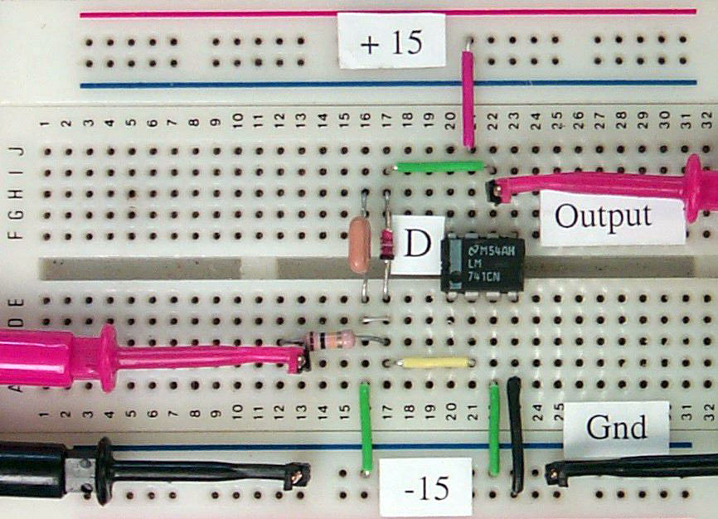

Figure 9-8 Component Layout for Op-Amp Log Amplifier

Investigate the operation of the logarithmic op-amp circuit by applying a variable amplitude DC voltage to the input pin 2. Plot the output voltage as a function of the input voltage on both a linear and logarithmic plot. How well does the circuit work for AC input signal levels?

